PENETRATION TESTING REPORT

FOOTPRINTING & NETWORK SCANNING PHASES
W2-PM-FINAL | CYBERSECURITY | NETWORKWALKS

Pentester Name  (Cybersecurity Professional) | SOLOMON ISAIAH DIRI
Program/Batch | B083-Networkwalks
Date | 17 SEPTEMBER 2026
Modules completed | W2-PM1 (Multiple Kali Tools)  W2-PM3(Maltego information Gathering)  W2-PM5 (Zenmap Scanning)
Client/Target | 1. Networkwalks (secured written permission already)  2. My own local LAN Network
Permission secured from client? | Yes
Phases covered | Phase 1: Reconnaissance & Footprinting  Phase 2: Scanning & Network Discovery  Phase 3-5: In Progress

1. Liability Disclaimer
I have carried out these activities exclusively on systems and devices for which I obtained explicit written authorization, or on devices/systems that I personally own. All content provided here is intended strictly for educational and research purposes. Under no circumstances should this information be used to violate the law.
The instructor, authors, and Networkwalks bear no responsibility for how this knowledge is applied. Full accountability for any action taken rests solely with the individual performing it. Misuse of this material can result in serious consequences, including criminal prosecution, substantial fines, job loss, and a lasting criminal record. It's important to note that in most jurisdictions, unauthorized access to a system is considered a crime regardless of whether any actual harm or damage occurs.

2. Introduction
This report documents the footprinting of the networkwalks.com domain using a range of Kali Linux tools (W2-PM1) and Maltego (W-PM3), along with scanning my own local network using Zenmap (W2-PM5). Two of the modules focus on the footprinting phase, while the remaining module covers the scanning phase — together illustrating how an attacker progresses from collecting publicly available information to mapping live hosts on a network. This work represents the Week 2 component of my ongoing internship program at Networkwalks.
All commands were executed in Kali Linux (for footprinting), Maltego, and on a Windows PC running Zenmap (for scanning). Each step outlined below includes the exact command used, the observed result, a supporting screenshot as evidence, and a brief explanation of why the finding is significant from an attacker's perspective.

3. Tools Used
The table below lists each tool used in this report and its purpose.
Tool | Purpose
Kali Linux & Windows | Operating systems used for reconnaissance activities
WHOIS | Find domain registration details (owner, dates, name servers).
whatweb | Fingerprint web technologies (server, CMS, plugins, IP).
nslookup | Resolve the domain name to its IP address using DNS.
curl -I | Read the HTTP response headers of the website.
wafw00f | Detect whether a Web Application Firewall protects the site.
dnsrecon | Enumerate all DNS records (NS, MX, SPF, TXT, SRV).
Maltego | Retrieve corporate email address
Zenmap (Nmap GUI) | Scan the local subnet to find live hosts, IPs and MAC addresses
Windows CMD | Local IP and MAC address identification

4. Activities Performed

4.1 Footprinting & Reconnaissance

I conducted reconnaissance on the networkwalks.com domain using six Kali Linux tools: WHOIS, WhatWeb, Nslookup, Curl, Wafw00f, and DNSRecon. Each tool served to gather a distinct category of information about the target.
I began with WHOIS to retrieve publicly available domain registration details and identify the domain's name servers. This provided insight into the domain's registration data and underlying hosting infrastructure.
Next, I used WhatWeb to identify the technologies powering the website. The scan revealed WordPress 7.0.4 and WP Download Manager 3.3.58, along with additional information exposed by the site.
Using Nslookup, I resolved the domain name to its corresponding IP address, which was identified as 192.232.216.135.
I then used Curl with the -I option to inspect the HTTP response headers. This revealed additional details about the web application and exposed the WordPress REST API endpoint, /wp-json/.
Next, I used Wafw00f to determine whether the website was protected by a Web Application Firewall. The scan identified ModSecurity (SpiderLabs) as the WAF in use.
I then used DNSRecon to enumerate DNS records, which returned information on name servers, mail servers, SPF/TXT records, service records, and DNS software details.
Finally, I used Maltego to retrieve corporate email addresses associated with networkwalks.com.

4.2 Network Scanning with Zenmap
For the second activity, I used Zenmap to carry out network discovery on my local network. The task required me to identify my local IP address and subnet, discover live hosts on that subnet, record their IP and MAC addresses, and generate a network topology map.
I began by using the Windows ipconfig command to determine my local IP address and LAN subnet. I then entered this subnet into Zenmap and ran a Ping Scan to identify active hosts on the network.
The scan results identified three live hosts, including:
- 10.36.251.1
- 10.36.251.90
- 10.36.251.162
Along with these, three corresponding MAC addresses were also recorded.
Once the scan was complete, I opened the Topology section in Zenmap, enabled the legend, and exported the network topology as a PDF, as required by the practical task.

5. Risk Analysis / Impact
Based on the information collected during the footprinting and network scanning activities, I identified the following potential risks.
# | Risk / Finding | Evidence / Observation | Potential Impact | Risk Level
1 | Web technology information exposed | WhatWeb identified the use of WordPress and the WP Download Manager plugin | Exposed technology and version information could help attackers identify software that warrants further security scrutiny | ● Medium
2 | Server IP address identifiable | Nslookup resolved the domain to 192.232.216.135 | Reveals information about the network location of the web service | ● Low
3 | HTTP technical information exposed | Curl returned HTTP response headers and revealed the /wp-json/ endpoint | Could assist with technology fingerprinting and further enumeration | ● Low
4 | WAF technology identifiable | Wafw00f identified the use of ModSecurity (SpiderLabs) | Discloses information about the web application's security architecture | ● Low
5 | DNS infrastructure information exposed | DNSRecon identified DNS, mail, and other service-related records | DNS information could help build a broader profile of the organization's infrastructure | ● Medium
6 | Corporate email retrieval | Maltego retrieved a corporate email address | Could be used by an attacker to send phishing emails | ● Medium
7 | Multiple live hosts visible on local network | Zenmap identified four live hosts in the example network | Unknown or unauthorized devices could potentially be present on the network | ● Medium

Risk level key: ● Critical ● Medium ● Low
The risks identified above are based on observations made during the footprinting and scanning exercises; they are not confirmed vulnerabilities.These practical exercises focused primarily on information gathering and host discovery. No exploitation or vulnerability validation was carried out as part of either module.As such, the presence of details such as a software version, IP address, or DNS record does not, on its own, indicate that a system is vulnerable. Additional authorized security testing would be needed to confirm whether any genuine vulnerability exists.

6. Recommendations
Based on the observations from these activities, I recommend the following security improvements:
- Review publicly exposed technology information
Organizations should regularly review what information about their web technologies, CMS, and plugins is visible to the public.
- Keep software up to date
CMS platforms, plugins, and other web technologies should be updated consistently and checked against current security advisories.
- Review HTTP headers
HTTP response headers should be reviewed periodically to ensure that unnecessary technical information is not being exposed.
- Review DNS records regularly
DNS records should be checked on an ongoing basis to confirm that only necessary information and services are publicly accessible.
- Properly configure and monitor the WAF
The WAF (ModSecurity) should remain enabled and properly tuned, as it is already effective in blocking basic, unsophisticated attacks.
- Conduct regular internal network discovery
Organizations should periodically scan their own networks to identify all active devices.
- Investigate unknown devices
Any unexpected or unrecognized device found during network scanning should be investigated and verified.
- Maintain network documentation
Network topology and device information should be documented and kept up to date.
- Perform security testing with proper authorization
Reconnaissance and scanning activities should only be conducted against systems and networks for which explicit authorization has been granted.

7. Conclusion
During Week 2 of my Cybersecurity & Ethical Hacking internship, I completed practical activities covering footprinting, reconnaissance, and network scanning.
In the footprinting activity, I used six Kali Linux tools alongside Maltego to gather information about the target domain. Through this, I learned that WHOIS can provide domain registration details, WhatWeb can identify web technologies in use, Nslookup can resolve domain names, Curl can inspect HTTP headers, Wafw00f can detect the presence of a WAF, and DNSRecon can provide additional DNS information. I also used Maltego to retrieve a corporate email address associated with networkwalks.com.In the network scanning activity, I used Zenmap to identify my local network configuration and discover active hosts on the network. I collected IP and MAC address information for these hosts and generated a network topology map.
These exercises highlighted how important information gathering is in cybersecurity. Even before attempting to exploit a system, a security professional can learn a great deal about an environment simply by carefully analyzing publicly available information and network responses.
I also learned the value of documenting technical findings clearly. A good cybersecurity report should explain what was performed, what was discovered, what the observation means, what risk it may pose, and what steps can be taken to reduce that risk.
Finally, I learned that reconnaissance and scanning must always be carried out within an authorized scope. These activities were completed as part of an assigned educational cybersecurity lab

8. Evidences Collected

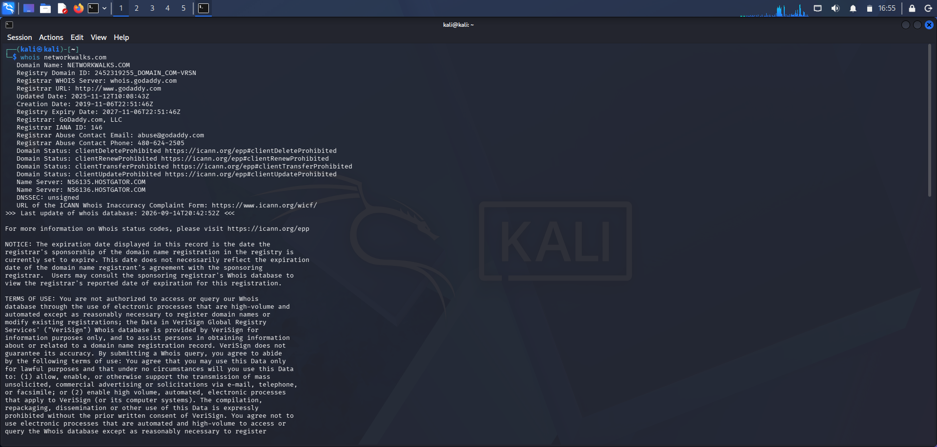

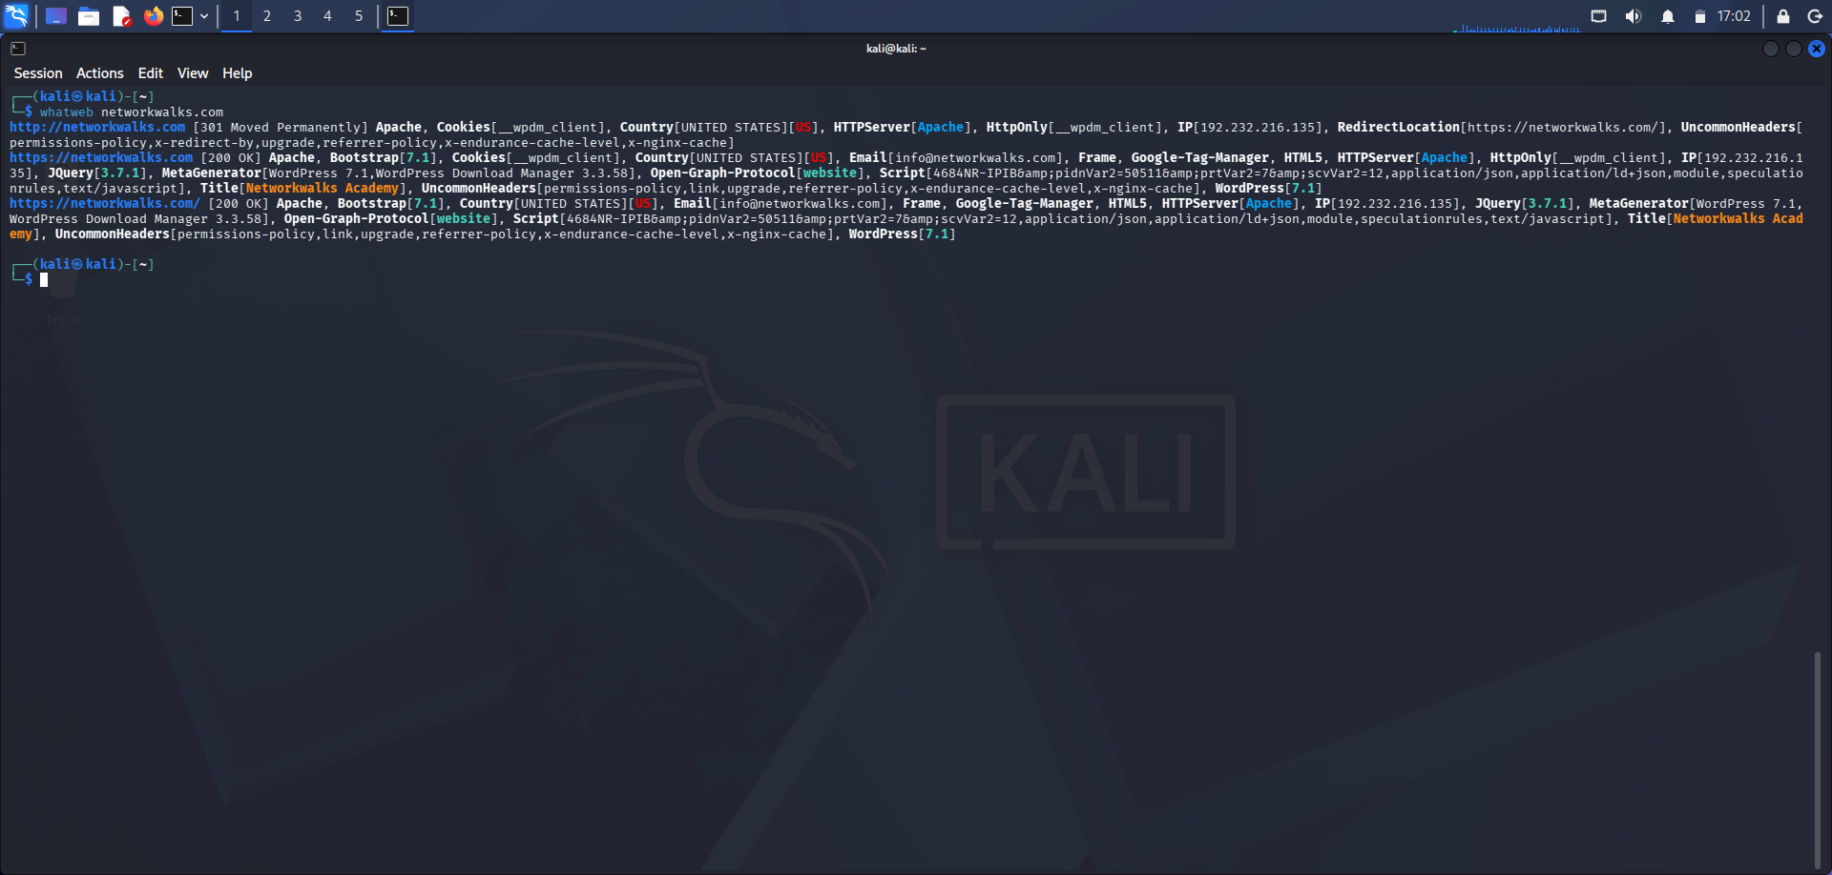

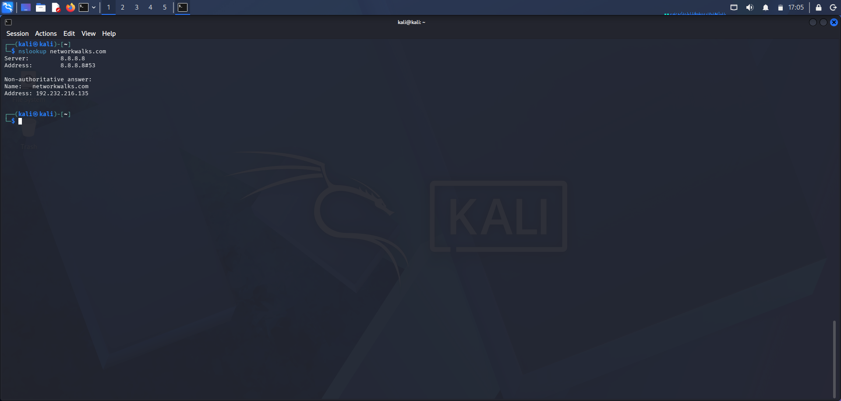

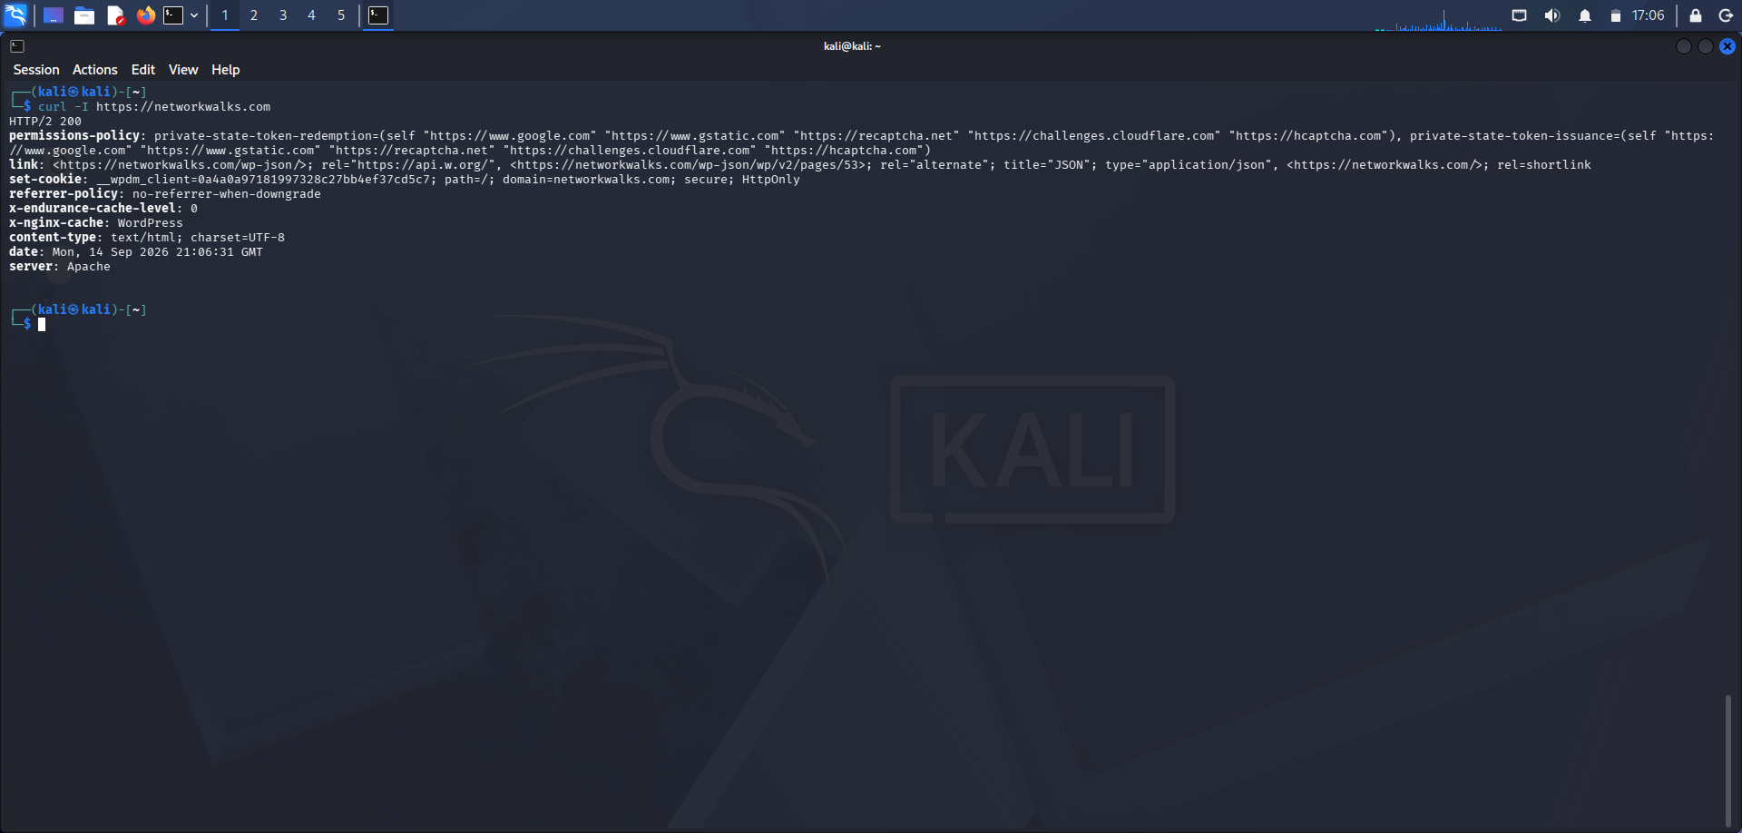
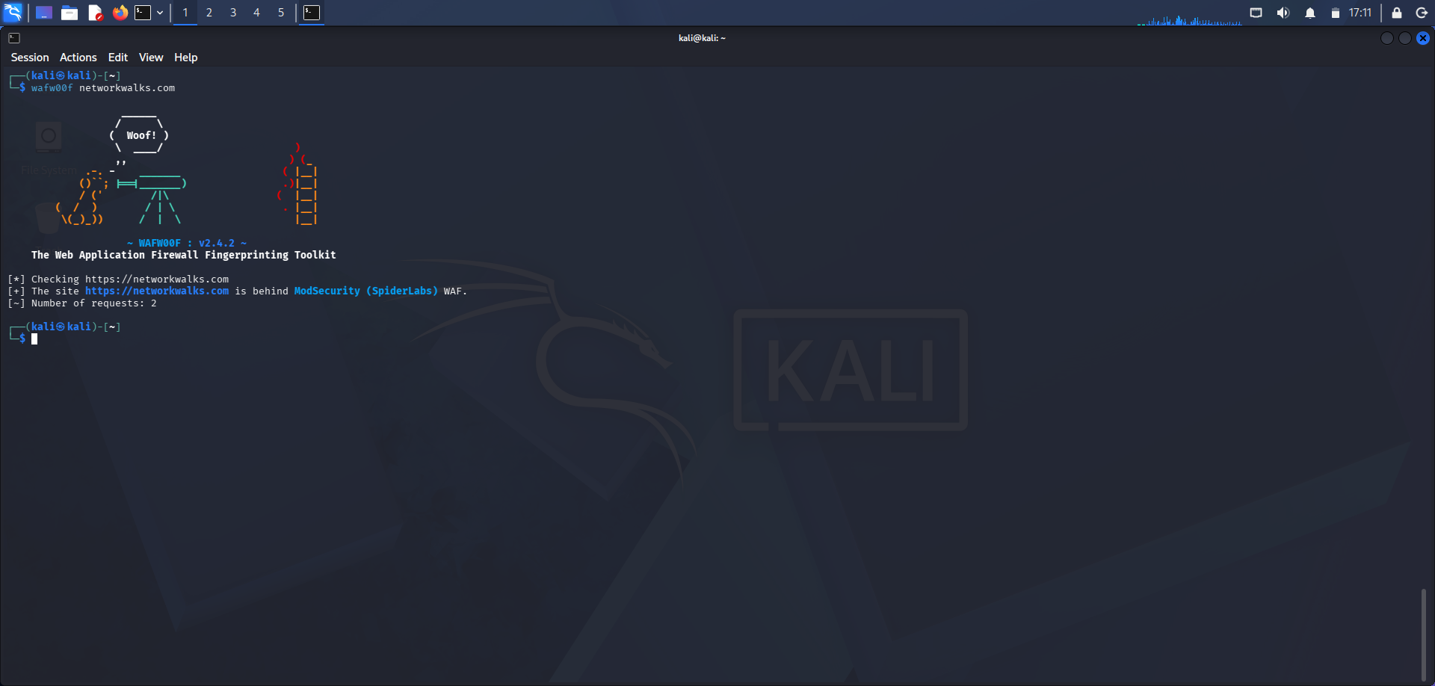

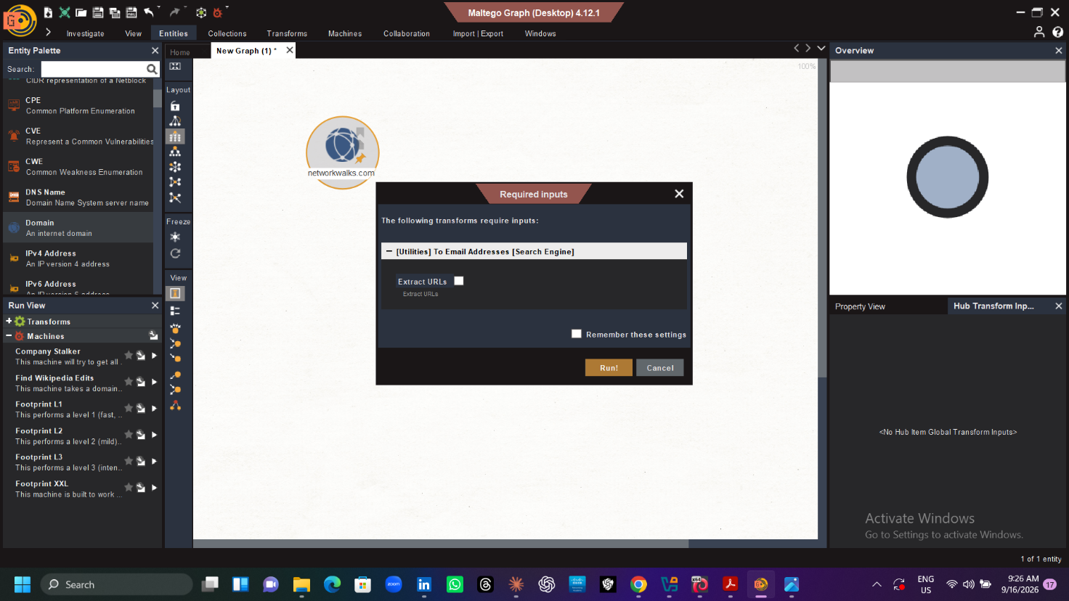
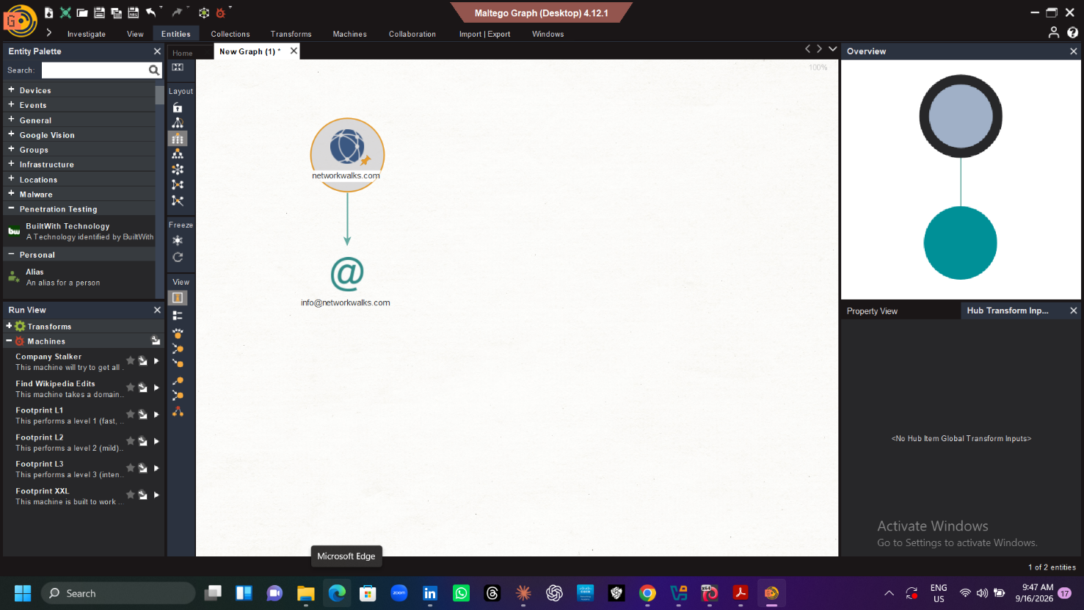
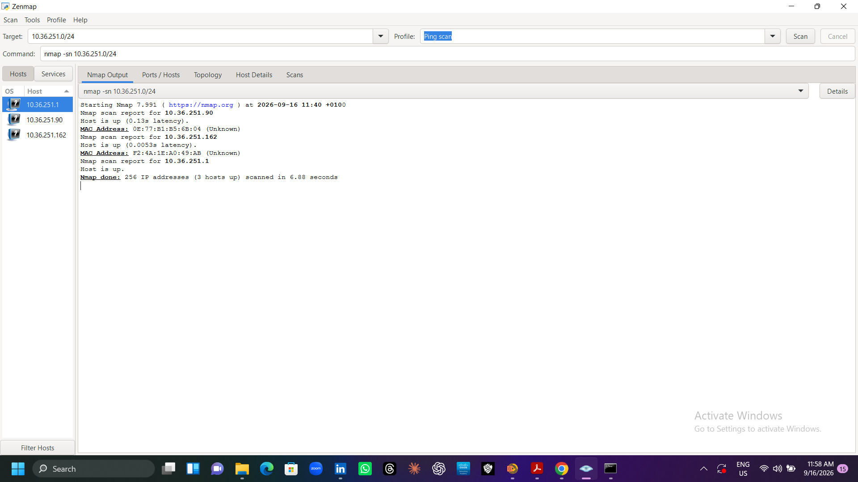
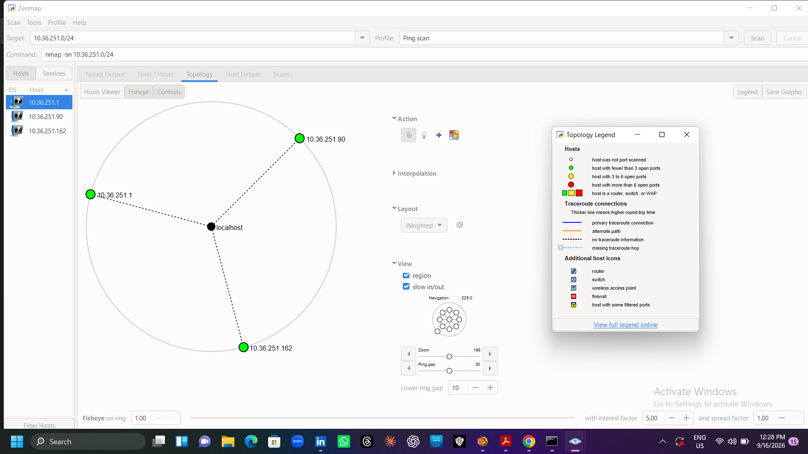

-End-

👤 Author
SOLOMON ISAIAH DIRI

Cybersecurity Intern B083

LinkedIn: https://www.linkedin.com/in/mcdiri/

Github :

📌 Project Information
Program Name: Cybersecurity Internship at Networkwalks | Week: 02 | Repository: GitHub

